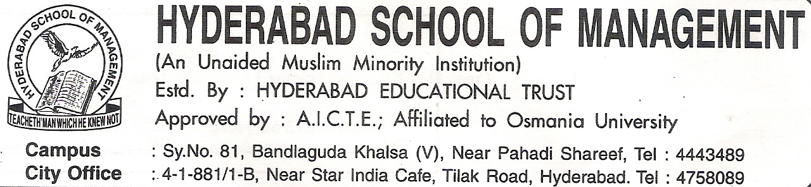


ADMISSION APPLICATION FORM - 20__ __

Read the instructions carefully for filling the common application form:

- Fill in the Application form in CAPITAL LETTERS using black ink.
- The Form should be complete in all respects. Incomplete Forms will not be considered for further processing.
- Please enclose Two (2) copies of recent passport size photograph and paste one in the box alongside.

For Office Use Only

Form No. | Admission Date: | Academic Year | Admission No. | Aggregate% at Degree Level / Equivalent: | Management /  Convenor

(To be filled by the Candidate in his/her own handwriting after reading the instructions)

- DETAILS OF ENTERENCE TEST:
Year | Hall Ticket No. | Marks Obtained | Rank

- Name of the Applicant
(IN BLOCK LETTERS)

- Date of Birth
(DD/MM/YYYY)

- Gender Male Female
- Marital Status Single Married

- Religion

- Blood Group
(Enclosed Blood Test Result)

- Nationality

- Do you have Passport Y N If yes, Expiry Date (DD/MM/YYY)

- Father’s/Guardian’s Name
(IN BLOCK LETTERS)

- Father’s/Guardian’s Occupation

- Contact No.

- Company Name

- Exact Designation
- Contact Details

- State

- Pin/Zip

- E-Mail Id

- Permanent Address

- State

- Pin/Zip

- E-Mail Id

- Phone Number

- Land Line
4
0
0

- Education Background

Level |  |  |  | Subjects | Aggregate Makrs/Devision






Any Other Qualification

- Details of any Period of Employment, if any:-

- Do you required on campus accommodation during the period of Your study at H.S.M (Tick Appropriate Box):

- Do you required Transportation Facilities (Tick Appropriate Box):

- In case of emergency (Other than Parents):

Name of the Contact Person | Address | Tel. No.(Res; Off.) & Mobile

- Participation in Extracurricular Activities: ..................................................................................................................................................................................................................................................

................................................................................................................................................................................................................................................
(Attach separate sheet mentioning your special achievements if any.)

- Hobbies / Special Interest:
..................................................................................................................................................................................................................................................

.................................................................................................................................................................................................................................................

- How did you come to know about the Institute and the program?
Friends/Family Newspaper Magazine Website Other Sources

Specify the name of magazine/newspaper/website/other sources

- Declarations:

HYDERABAD SCHOOL OF MANAGEMENT
# Osman Plaza 2nd Floor Masabtank,
Beside cresent Hospital

Sir,
I wish to apply for admission to Hyderabad School of Management, and promise to abide by the Rules
& Regulations of the Institute. I certify that the information given by me in this application form is correct and
complete to the best of my knowledge and belief. I understand and agree that misrepresentation or omission of
facts will justify the denial or cancellation of admission, or expulsion. I further declare that I shall submit myself
to the disciplinary jurisdiction of the Director of the Institute.

I have read and do hereby consent to abide by the terms and conditions of admission as mentioned in the
prospectus.

Signature of the Candidate
Place.....................
Date......................
Parent’s Declaration

I undertake that my son / daughter ......................................................................................................... applying
for admission to ......................................................... course will be subjected to the Institute’s disciplinary Rules
and Regulations. I further undertake to pay all the dues of the Institute in time.

Date: Signature of the Parent

- Fee Particulars :(Cash / Cheque / D.D_____________________ Instalments:_______________________

Remarks:-

35. Documents Check List
S.no | Particulars | Checked
1 | 15 Passport Size Photos | Y N
2 | ICET Hall Ticket | Y N
3 | ICET Rank Card | Y N
4 | Allotment Letter | Y N
5 | X & Inter Certificates | Y N
6 | Provisional degree certificate & Memorandum of Marks of Degree Examination (I, II, III Year) | Y N
7 | Bonafide – X, XI, XII | Y N
8 | Transfer Certificate | Y N
9 | Income Certificate | Y N
10 | Ration Card | Y N
11 | Six (6) copies of all the above documents | Y N

Check and Verified by_______________

Signature_________________________

Admission Provisionally Recommended

Chairman(Hon) Managing Director

Hyderabad School of Management

………………………………………………………..

Acknowledgement

Form No.__________

Name .............................................................................................. Registration No. .............................................

Checked By ................................................................................... Signature .......................................................

Hyderabad School of Management

